This time the task will be a bit unusual, because you will have to do your own research and implement a mechanism for displaying the main image of the object on its form using a connection to the FilesOperations subsystem.
Your task is to connect the existing _DemoStorageLocations catalog to the FilesOperations subsystem so that the item form displays a submenu for working with files and a hyperlink "Attachments" (exactly the same as in the theoretical part of the lesson), the list form would have a "Paperclip" column, which would display a picture of a paperclip for storage locations containing attached files (exactly the same as in the theoretical part of the lesson), but in addition, you need to implement the attachment and display of the main image for the storage location on the item form (see the screenshot of the _DemoProducts catalog item form):
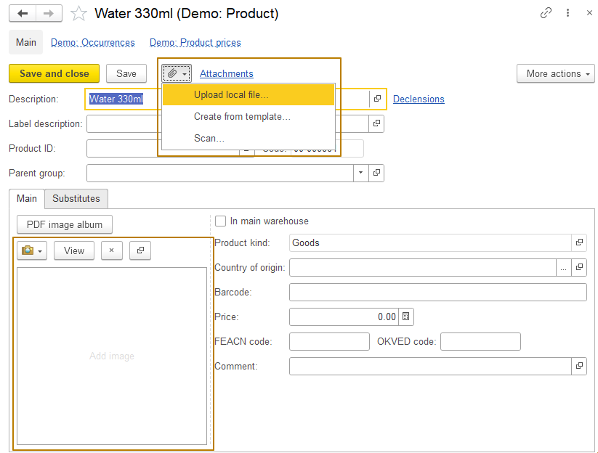
Note: Files for storage locations should be stored in a separate catalog, not the general "Files" catalog.
In general, there is nothing complicated about this, but you will have to independently determine what changes need to be made to the configuration for it to work. Test the work thoroughly after making changes, the main image should be displayed not only after attaching it to an open form by clicking on the square of an image field on a form, but it should also be displayed after saving the object, closing the form and reopening it. The buttons "View", "Clear", "Open the attachment card" and the buttons in the submenu for working with images on the same panel should also work:
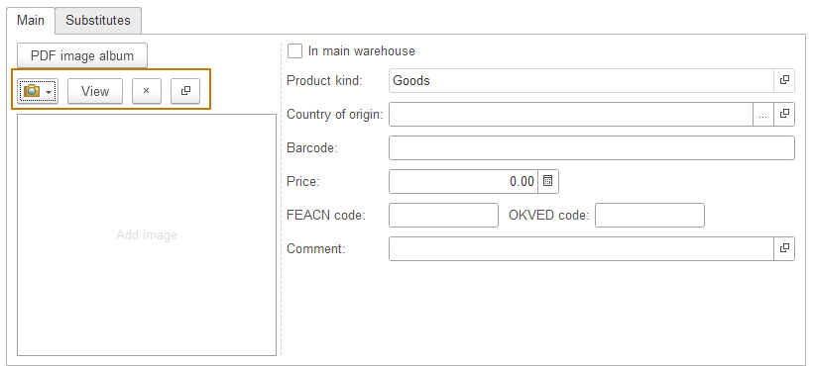
The button "PDF image album", which is on the _DemoProducts catalog form, does not need to be added.

Note: do not forget about marking the module using areas if you add procedures and functions to it.

Tip: Do not be afraid to edit the visual part of the _DemoStorageLocations form if you think it is necessary.

